**Supplementary Figures:**

**Spatial and temporal patterns of stream nutrient limitation in an Arctic catchment**

Demian Hauptmann*1, Maria Myrstener1,2

*1 Department of Ecology and Environmental Science, Climate Impact Research Centre, Umeå University, Umeå, Sweden*

*2 Department of Forest Ecology and Management, Swedish University of Agricultural Sciences, Umeå, Sweden*

Corresponding author: Demian Hauptmann ([Hauptmann.demian@gmail.com](mailto:Hauptmann.demian@gmail.com))

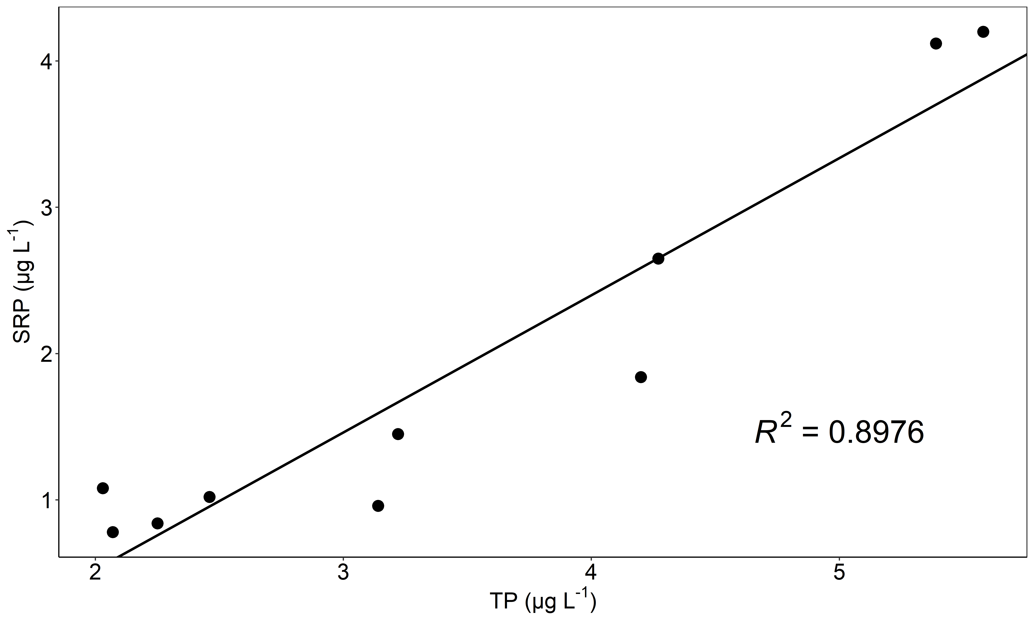

**Fig. S1** Bivariate plot of SRP and TP for seasonal data with regression line and corresponding R2

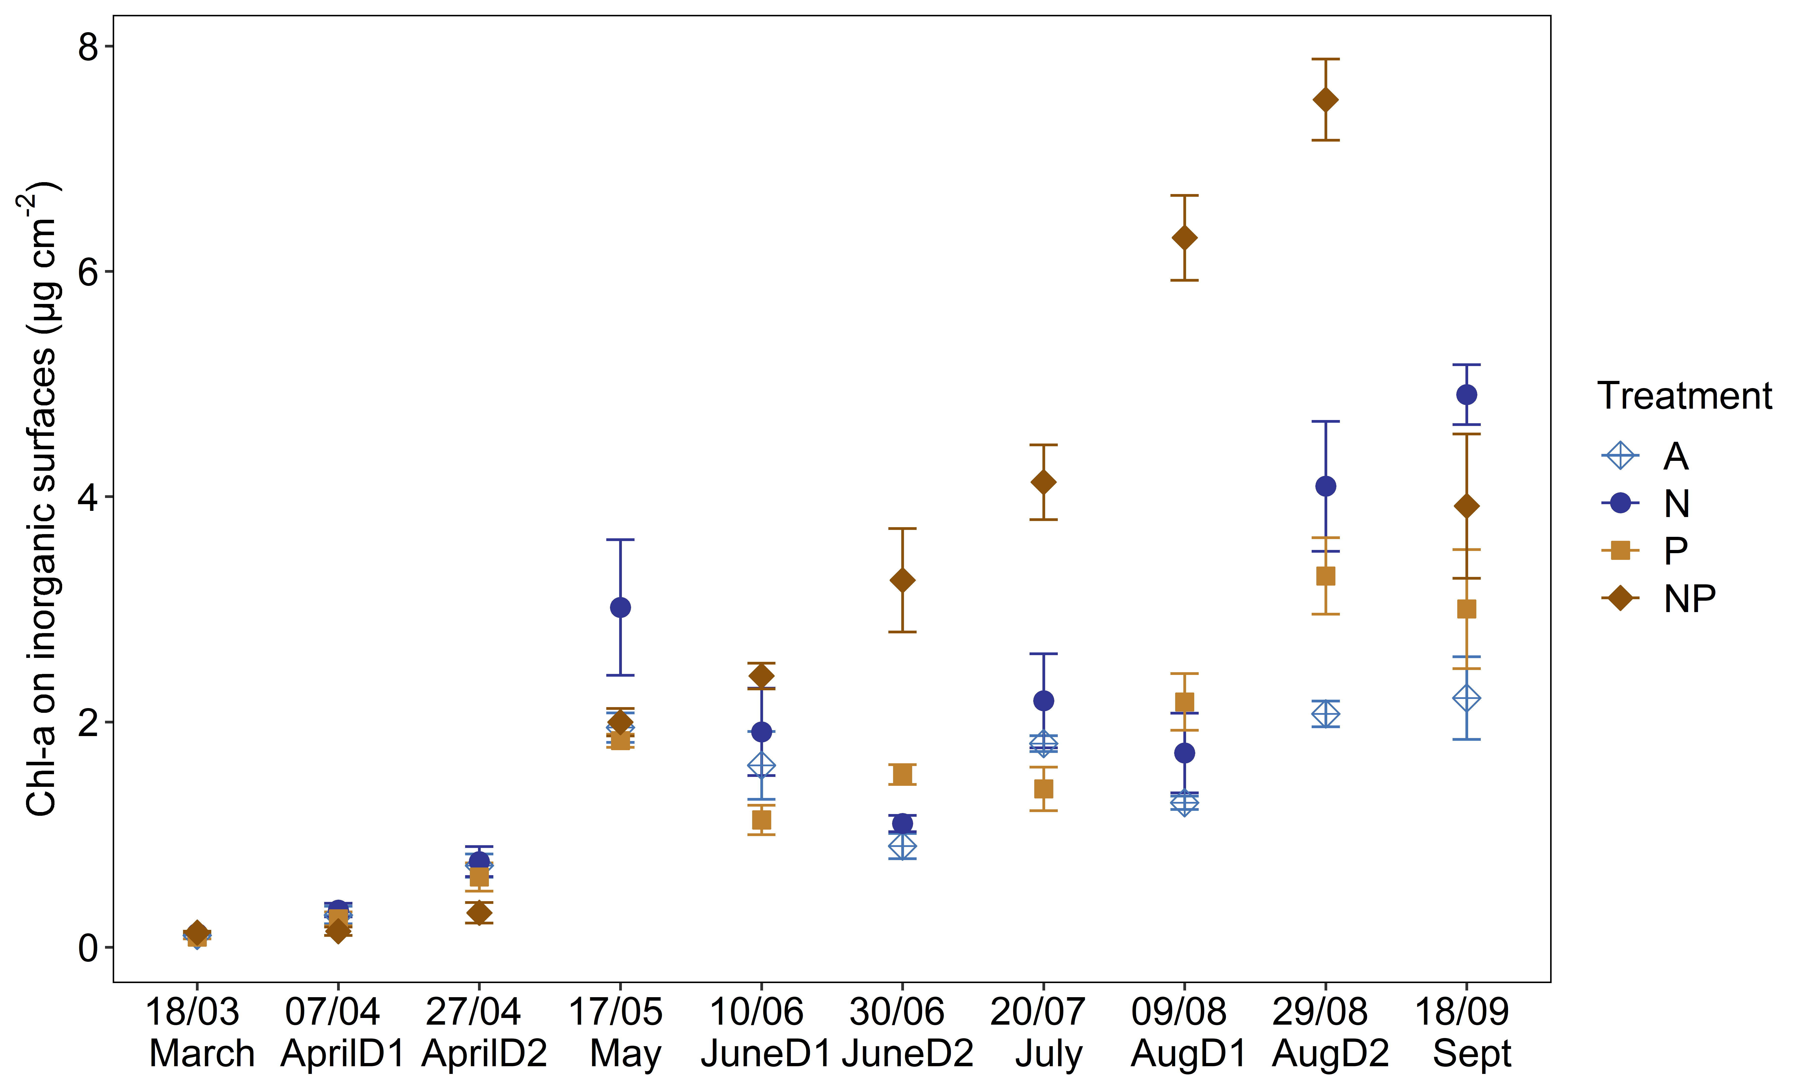

**Fig. S2** Average Chl-a accumulation on inorganic surfaces with four treatments (A, light blue; N, dark blue; P, light brown and NP, dark brown). Error bars denote standard error with confidence interval (ci=0.95). The x-axis shows the day in the middle of the deployment and the name based on the majority of deployment days per respective month (see Tab. 1). Average seasonal Chl-a accrual per treatment was: A=1.295 μg cm-2, N=2.014 μg cm-2, P=1.534 μg cm-2 and NP=3.011 μg cm-2

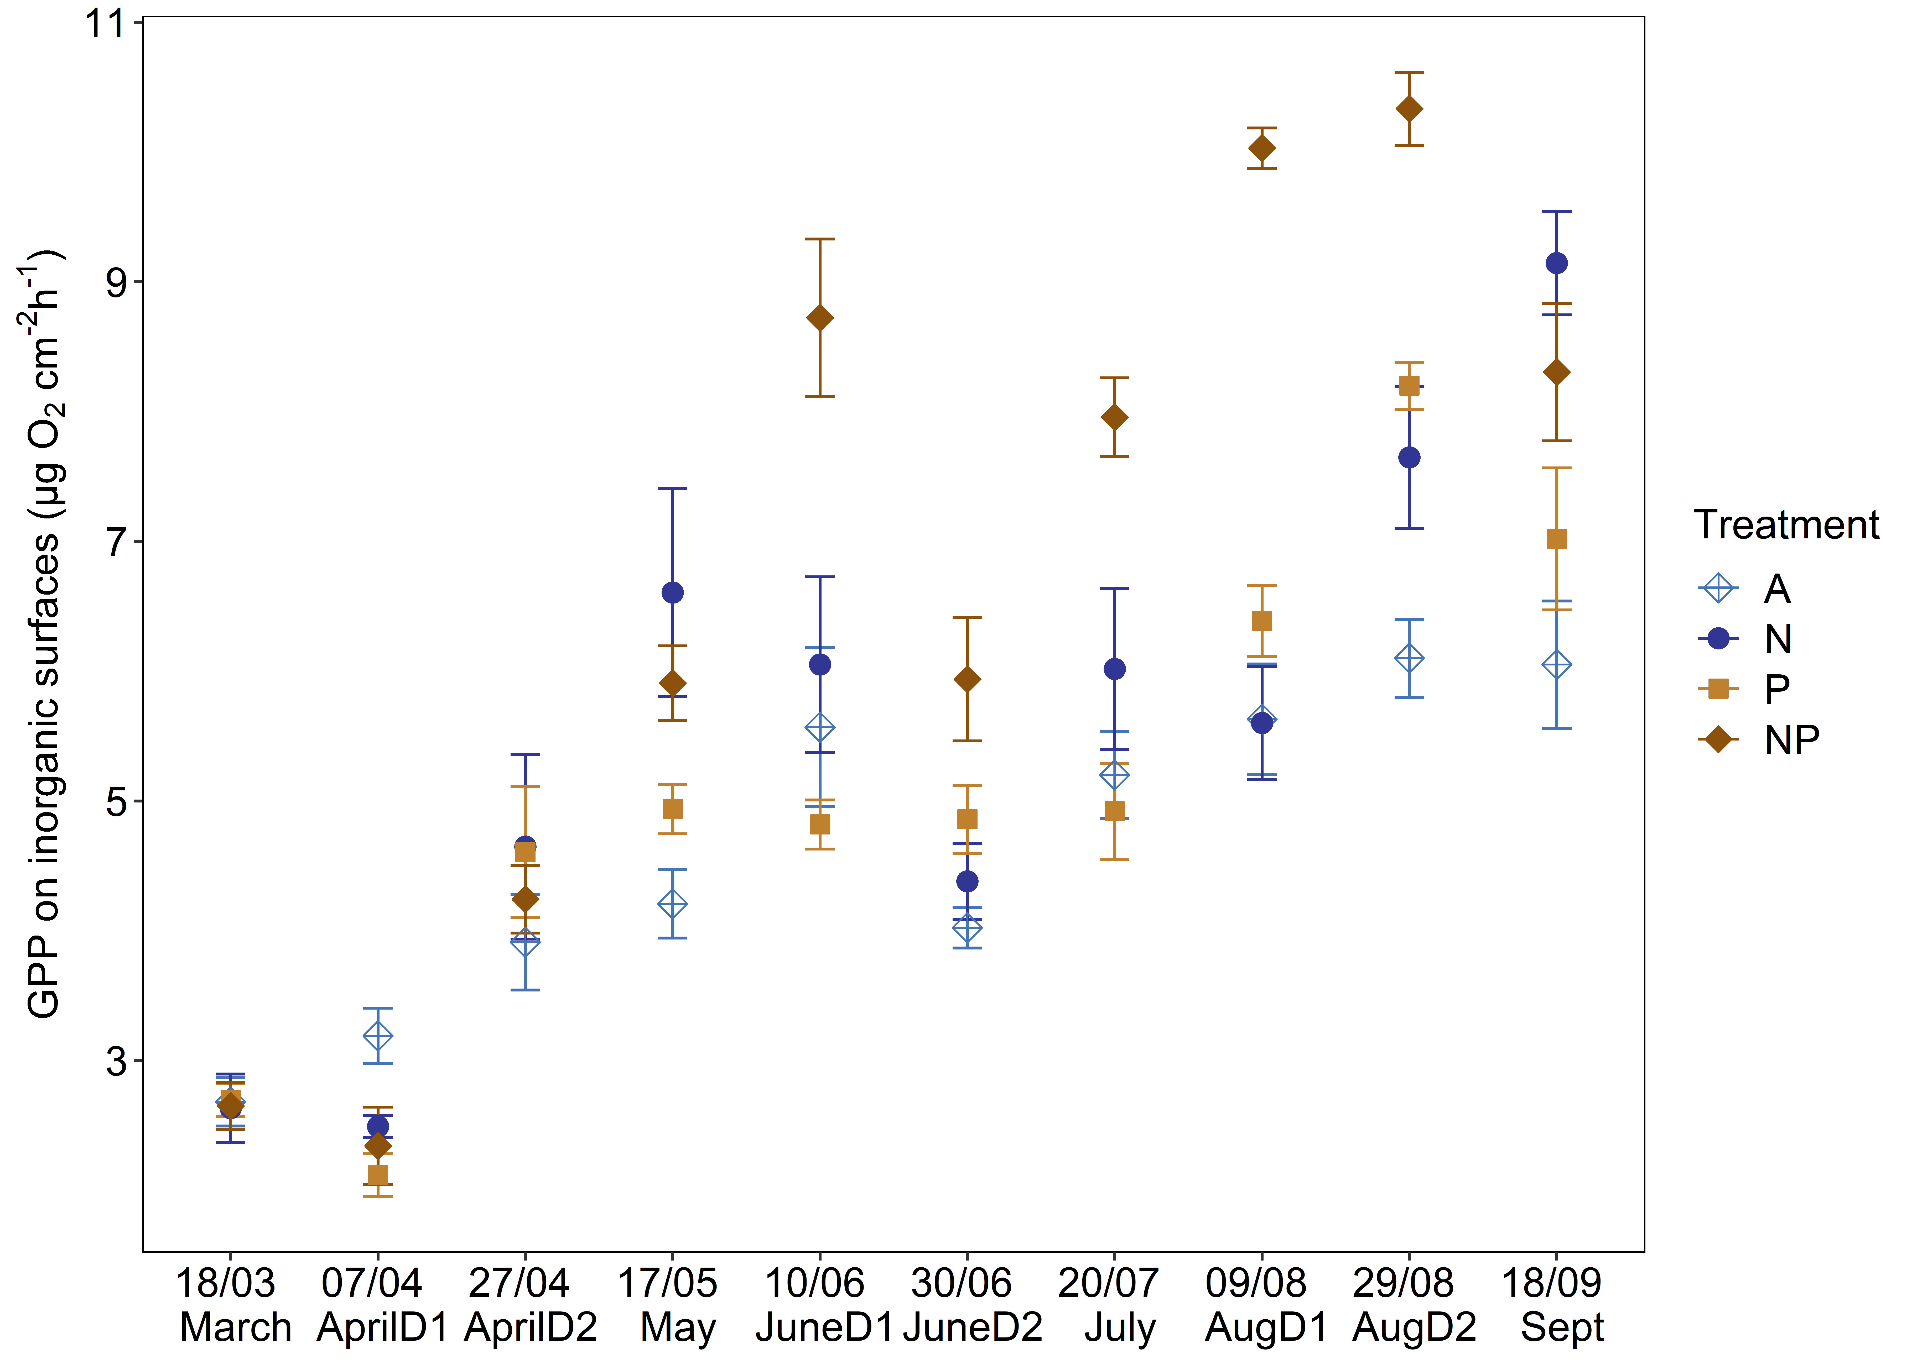

**Fig. S3** Average GPP rates on inorganic surfaces with four treatments (A, light blue; N, dark blue; P, light brown and NP, dark brown). Error bars denote standard error with confidence interval (ci=0.95). The x-axis shows the day in the middle of the deployment and the name based on the majority of deployment days per respective month (see Tab. 1). Average seasonal GPP accrual per treatment was: A=4.656 μg cm-2, N=5.521 μg cm-2, P=5.056 μg cm-2 and NP=6.642 μg cm-2

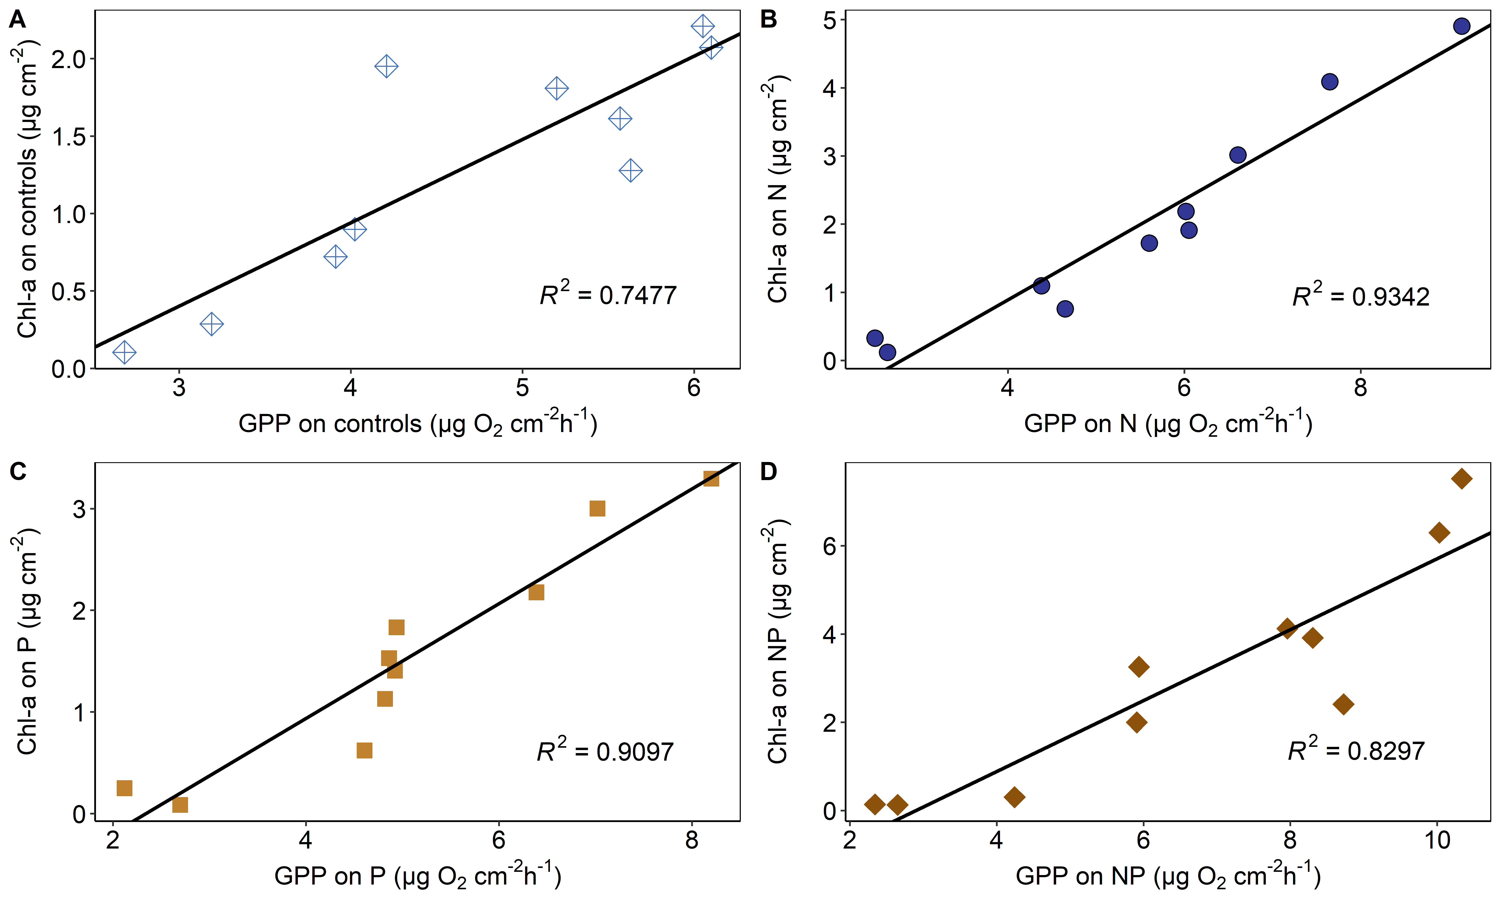

**Fig. S4** Bivariate plots of autotrophic Chl-a accumulation and GPP for each treatment (A, light blue; N, dark blue; P, light brown and NP, dark brown) with linear regression and the corresponding R2 values

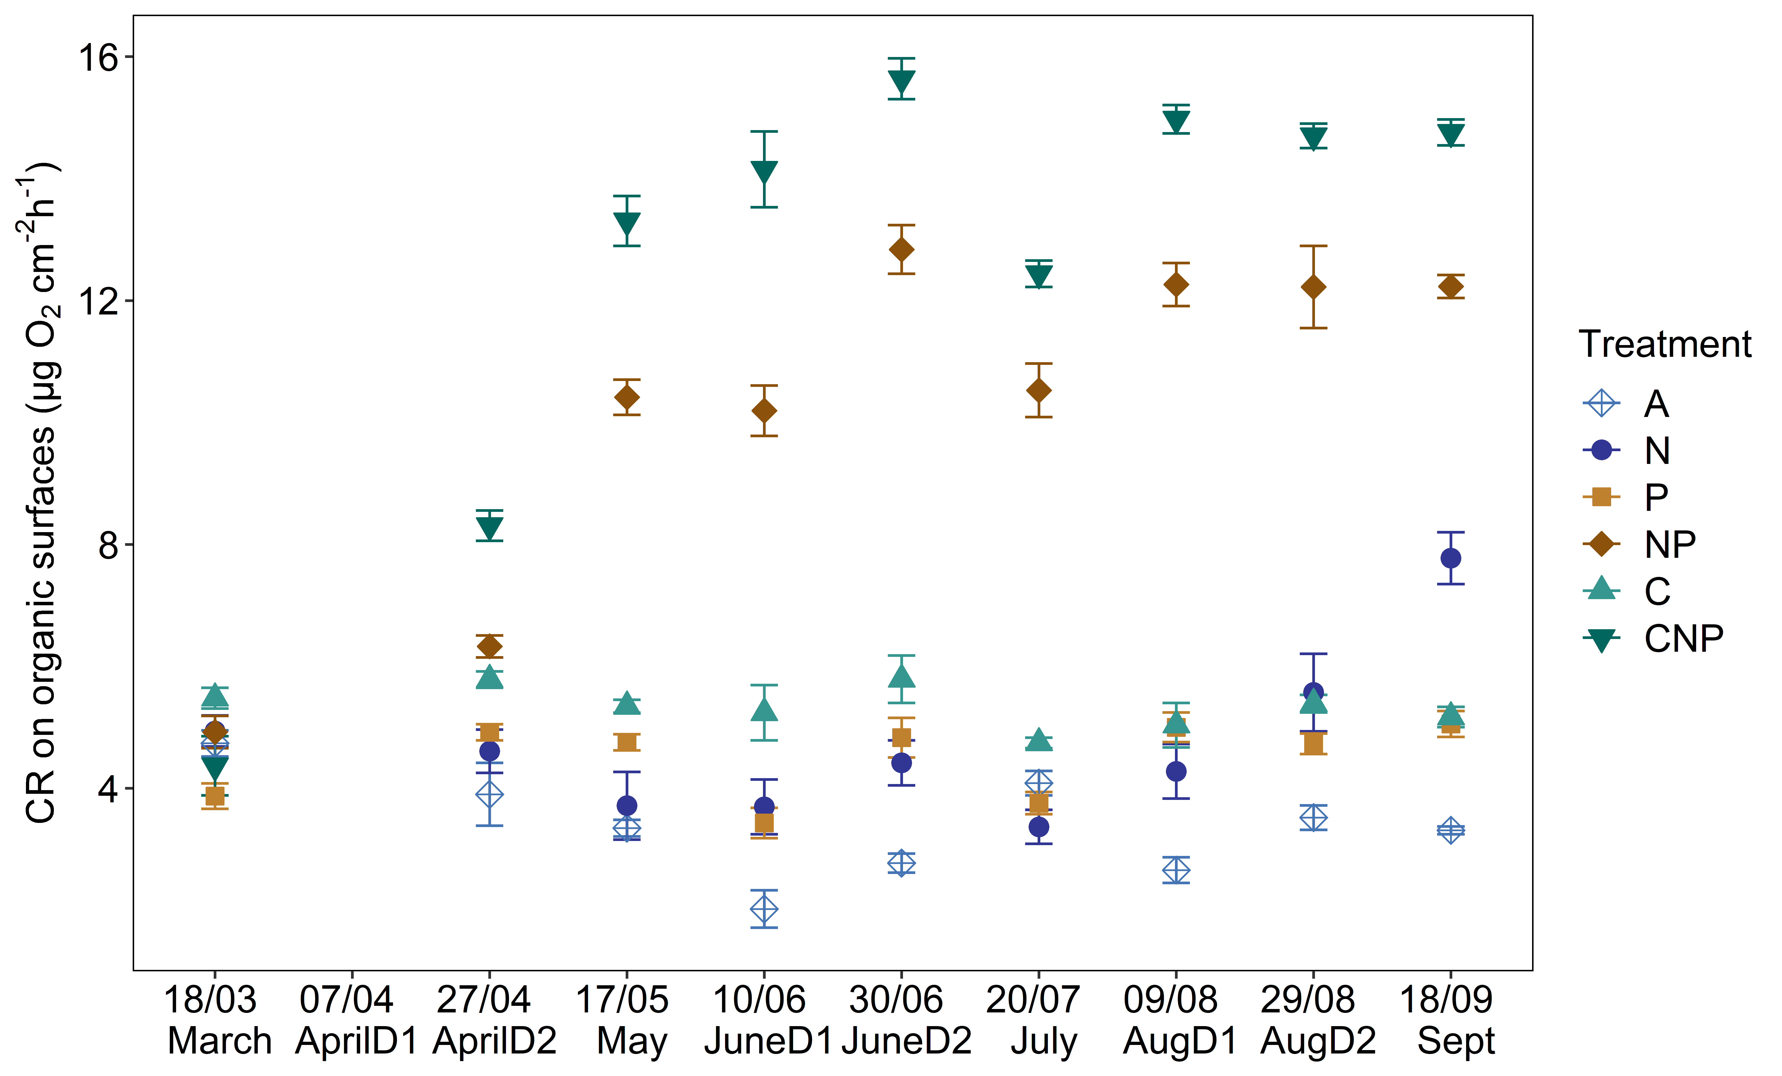

**Fig. S5** Respiration rates on organic surfaces (μg O2 cm-2 h-1). Error bars denote standard error with confidence interval (ci=0.95). Data for AprilD1 are missing because we changed the growing surface from cellulose sponge to birch veneer, but yielded incomparable results and hence decided to swap back to cellulose sponge. A=3.218 μg O2 cm-2 h-1, N=4.427 μg O2 cm-2 h-1, P=4.208 μg O2 cm-2 h-1, NP=9.498 μg O2 cm-2 h-1, C=4.995 μg O2 cm-2 h-1 and CNP=11.577 μg O2 cm-2 h-1

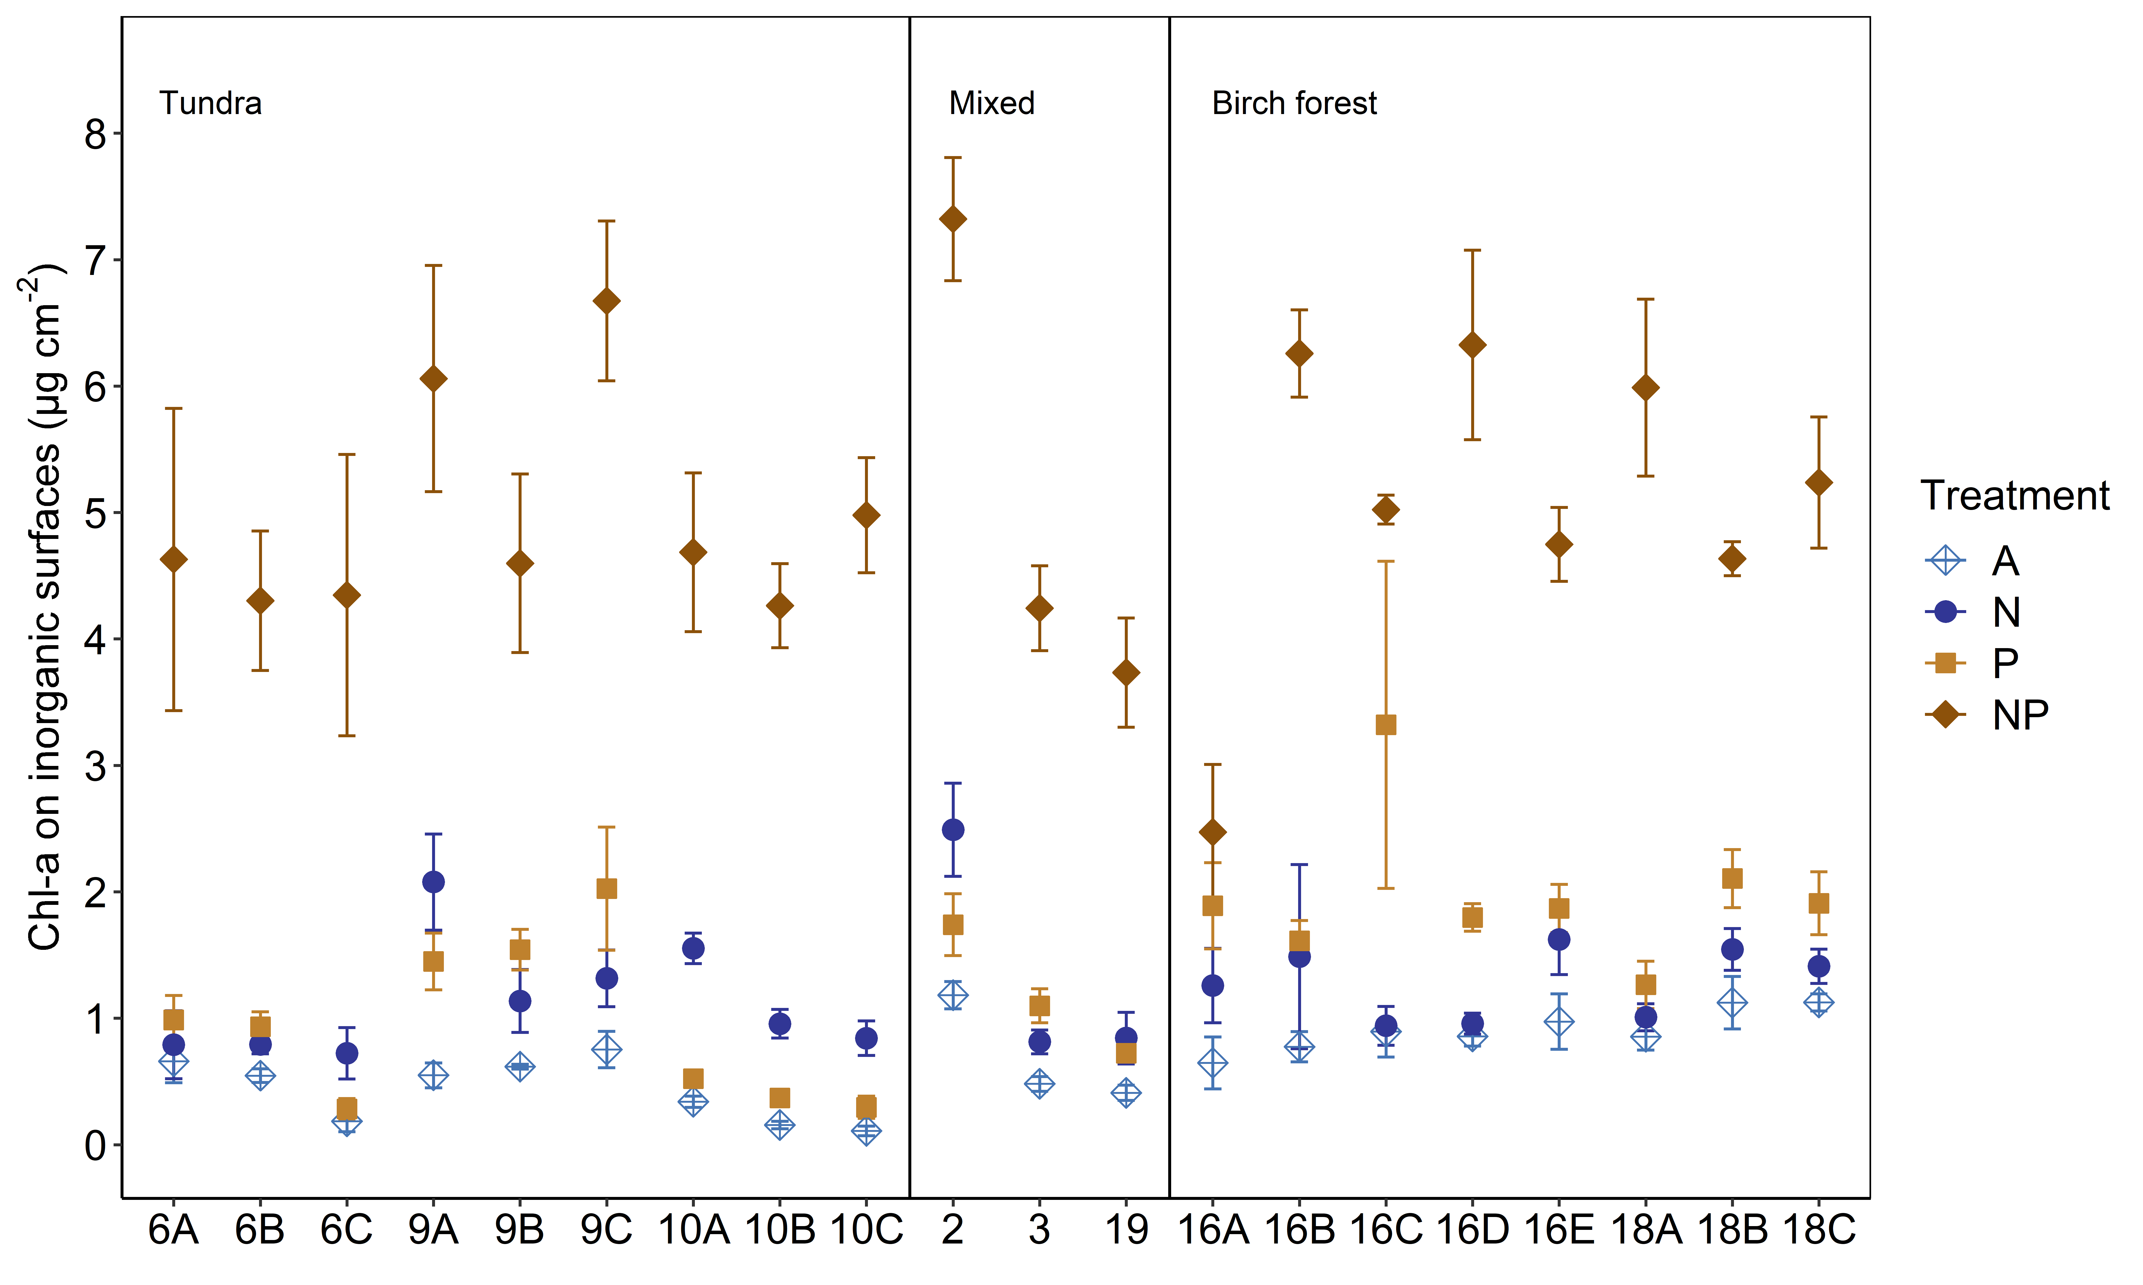

**Fig. S6** Chl-a accumulation on inorganic surfaces (μg cm-2) separated by site and treatment treatments. Lines separate vegetation/landscape features that are mentioned in Tab. S1, Fig. 1 in 2.1. Mixed sites are also located in the birch forest. Averaged (20 sites) Chl-a accumulation: A=0.662 μg cm-2, N=1.229 μg cm-2, P=1.387 μg cm-2, NP=5.026 μg cm-2

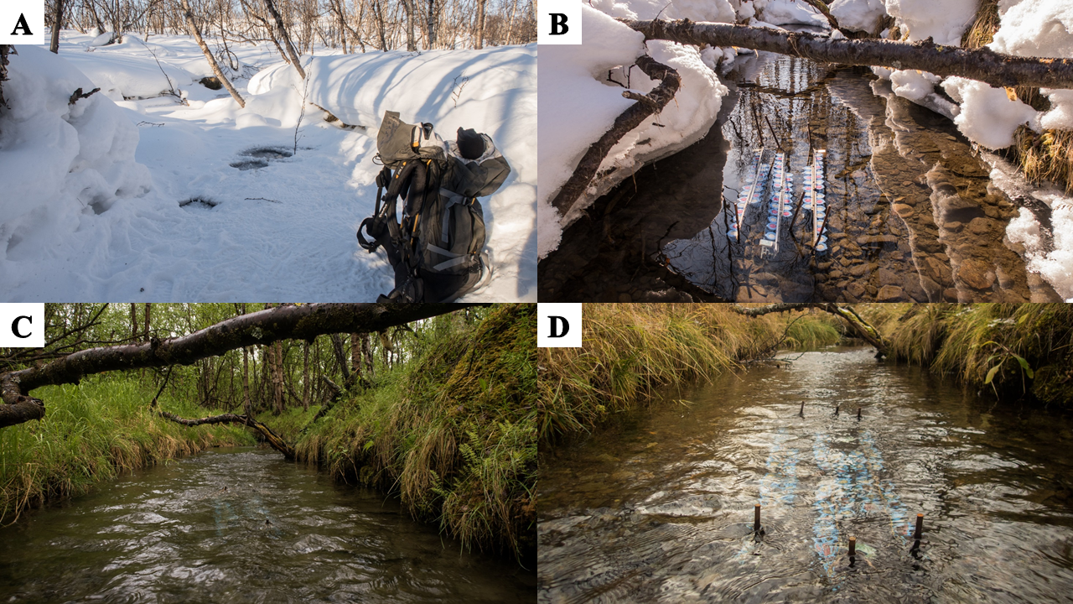

**Fig. S7** Images of seasonal changes of ice- and snow-cover as well as vegetation at site M18. A: D1, 08.03.2018; B: D3, 17.04.2018; C: D6, 20.06.2018; D: D10, 28.09.2018

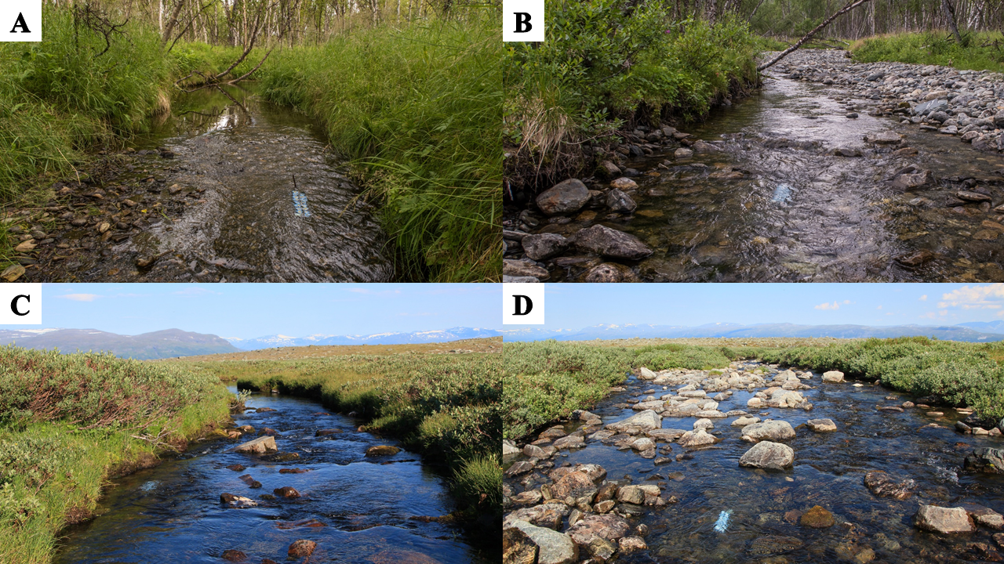

**Fig. S8** Spatial survey sites displaying the difference in riparian vegetation and morphology. A: M18C, Birch forest; B: M2, Birch forest/Main stem; C: M10A, Tundra; D: M9B, Tundra