Response to Reviewer 1 Comments

Thank you very much for giving us an opportunity to revise our manuscript. And we gratefully appreciate for the time spending and your constructive remarks and valuable suggestions, which has significantly raised the quality of the manuscript and has enabled us to improve the manuscript. We have studied your comments in detail. Each suggested comment was accurately incorporated and considered. According to your suggestions, we have made a careful revision on the original manuscript. All revised portions are marked in red in the revised manuscript which we would like to submit for your kind consideration. Our response to your comments is as follows:

**Point 1:***Line 25*

Replace “For lithology” with “Regarding lithology”

**Response 1:**

Thanks for your comments. We have made changes in the manuscript (please see line 25).

**Point 2:** *Line 28*

Replace “landslide sensitivity mapping” with “landslide susceptibility mapping”

**Response 2:**

Thanks for your comments. We have made changes in the manuscript (please see line 28-29).

**Point 3:** *Introduction*

Landslide database in Greece is also suggested to include in the reference list of the European Countries with available landslide databases.

Sabatakakis, N.; Koukis, G.; Vassiliades, E.; Lainas, S. Landslide susceptibility zonation in Greece. Nat. Hazards 2013, 65, 523–543. <https://doi.org/10.1007/s11069-012-0381-4>

**Response 3:**

Thanks for your comments. We strongly agree with your suggestion to complete our manuscript by including Greece among the European countries with available landslide databases. We have cited this article in the manuscript (please see line 55).

**Point 4:** *Introduction* (*Line 69*)

Please clarify the landslide causal factor meaning with the term “water sensitivity”. Do the

authors mean sensitivity to the erosional force of water, are they referring to the influence of

rainfall on landslide activation or both? Rephrasing by using more accurate landslide causal

factor terminology will add clarity to the text.

**Response 4:**

Thanks for your advice. The “water sensitivity” of loess refers to: the disintegration, wetting and dissolution phenomena of loess in contact with water, followed by deformation phenomena such as rheology, liquefaction and sliding under load. Following your suggestion, we have reformulated this term in the manuscript in a refined way as the shrinkage of loess when it meets water (please see line 70-71).

References:

Peng, J.; Qi, S.; Williams, A.; Dijkstra, T. A. Preface to the special issue on “Loess engineering properties and loess geohazards”. *Eng. Geol.* **2018**,236.

Gao, G. Formation and development of the structure of collapsing loess in China. *Eng. Geol.* **1988**,25(2-4).

**Point 5:** *Introduction*(*Line 79-80*)

Instead high incidence of landslides it is maybe better to use the term “landslide occurrences”.

**Response 5:**

Thanks for your comments. We have made changes in the manuscript (please see line 81).

**Point 6:** *Study area* (*Line 89*)

Replace “in tectonics” with “in respect of regional tectonics” or “regarding regional tectonics”.

**Response 6:**

Thanks for your comments. We have made changes in the manuscript (please see line 90).

**Point 7:** *Study area*(*Figure 1*)

Please add a small of China in Figure 1a , showing the location of the study area within China. This can help international readers to better locate the study area within China.

**Response 7:**

Thanks for your suggestion, we have refined Figure 1a.

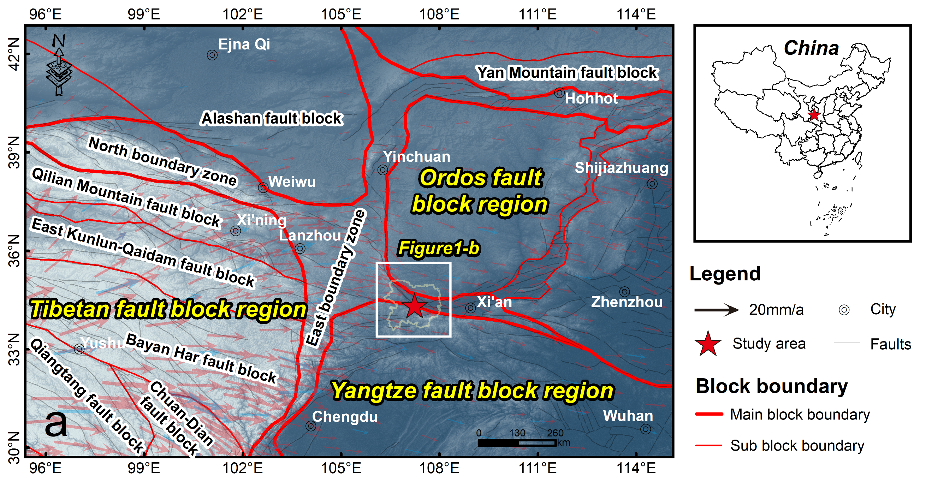

**Point 8:** *Study area*(*Line 108-113*)

Loess deposits cover only the Quaternary deposits or older formations as well? Maybe a longer and more detail description of the loess deposits regarding their extent and physical –mechanical properties, apart from grain size would add to the manuscript.

**Response 8:**

Thanks for your suggestion, we have described the temporal and spatial extent of the Loess deposits in more detail: it includes only Quaternary deposits, distributed in the Ordos Plate in the study area (please see line 109-110). In addition, in Section 1, We have described the physical–mechanical properties of Loess deposits (please see line 70-71).

**Point 9:** *Study area* (*Line 115*)

Term “horblende” is mostly used to denote that the main rock-forming mineral is hornblende. Please use the term that best corresponds to the rock type (e.g. amphibolite or hornblende gneiss or other) according to the literature and your knowledge of the study area.

**Response 9:**

Thanks for your comments. We have described the term hornblende more accurately as hornblende gneiss (please see line 117).

**Point 10:** *Study area* (*Line 115-120*)

In the introduction abstract says that “Loess Plateau is one of the most earthquake-prone areas in China due to its complex geological background and intense tectonic activity, leading to a large number of earthquake landslides ”

But in the manuscript says that

According to the China Earthquake Networks Center 115 (www.cenc.ac.cn), three earthquakes of Ms>3 have occurred in the study area, all of which are located in Long County, the northwest corner of Baoji.

Earthquake Magnitude >3 is not a clear sign of strong earthquake activity. Please clarify the earthquake magnitudes. It is not clear that earthquakes in the study area are big or not. Please give a range, if possible, eg. 3<Ms<5 or other according to your knowledge of the study area.

Also the identification of three earthquakes is not (as a number) and indication of frequent earthquake activity. Please clarify the time frame of the earthquake observations (e.g. during a certain time period).

Finally, regarding precipitation class please give a more accurate range of the annual

rainfall or provide a more accurate description of the term “more than 600mm)”. Is it

approximately 600mm or another value?

**Response 10:**

Thanks for your comments. We have added earthquakes that have occurred in the study area and adjacent areas (100 km buffer) to the manuscript; they are listed in Table 2. For the earthquakes mentioned, details of their location (Figure 2), time of occurrence, and magnitude are included. Your suggestion is very helpful because historical earthquakes are likely to be the triggering conditions for slope failure, which also plays a role in explaining landslide distribution.

Regarding precipitation class, we have determined the specific range and plotted the precipitation data for the last 10 years for six rain gauges in and around the study area in Figure 3, which would give a better visualization.

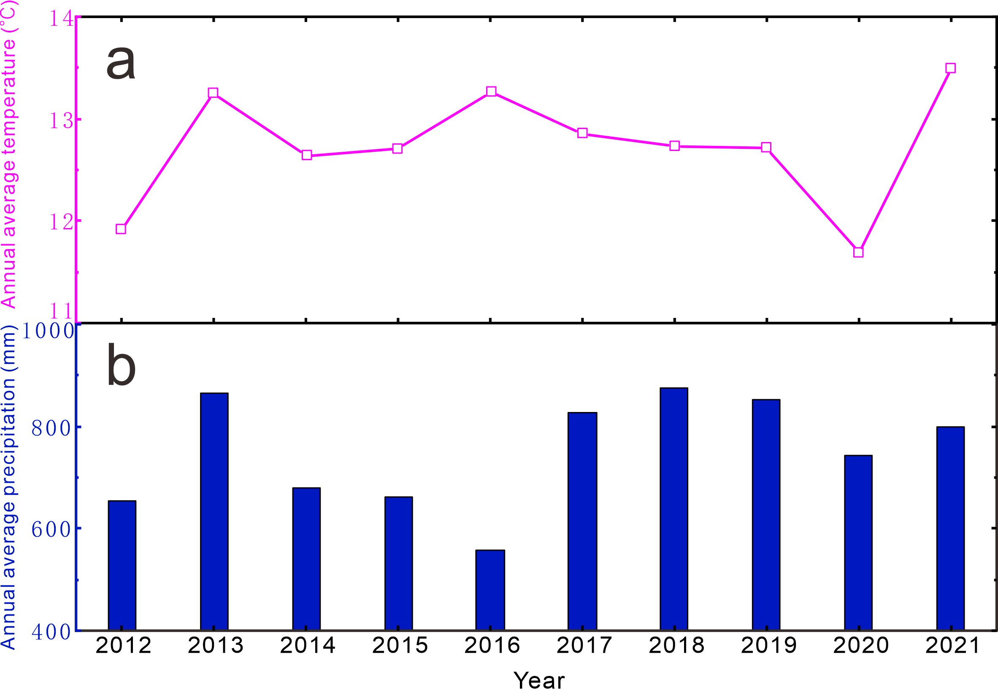

Figure 3. Annual average temperature (a) and annual average precipitation (b) from six meteorological stations (time period:2012-2021) around the study area.

**Point 11:** *Landslide inventorying.*

Please correct chapter title to “landslide inventory”

**Response 11:**

Thanks for your comments. We have made changes in the manuscript (please see line 128).

**Point 12:** *3.2. Inventory of large landslides.*

There is not in the manuscript a description of the findings of the statistical results of the landslide inventory, according to the findings in Figure 3.

**Response 12:**

Thanks for your comments. We have illustrated the results of Figure 3 in the manuscript (please see line 153-161).

**Point 13:** *Figure 3*a) top and right side histograms.

It would be maybe better to not include the point “cloud” in the graphs. The histograms provide the necessary information regarding the distribution of the recorded landslides. Having the points overlapping the histogram make the figure not clear.

b) landslide distribution map.

What is the difference between the large and small circles? Please provide information in the legend.

**Response 13:**

Thanks for your suggestion, we have modified and refined the figure.

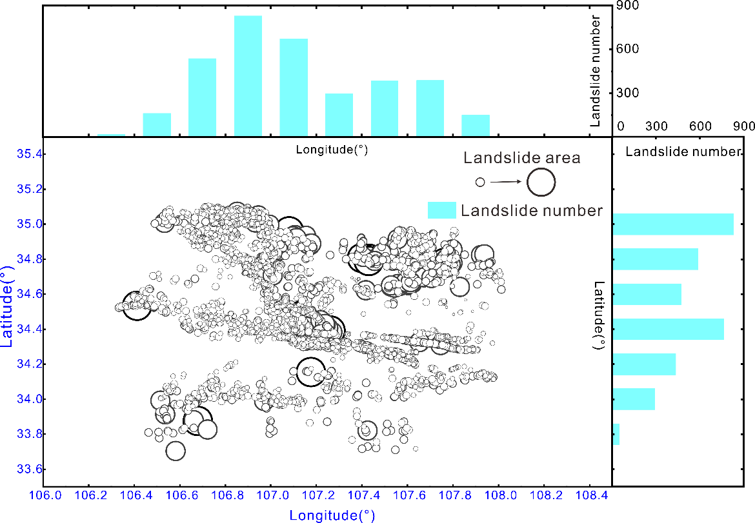

**Point 14:** *GIS spatial analysis of landslides.**4.1. Influencing factors selected.*

Please either omit word “selected” or correct title to “Selected influencing factors”

**Response 14:**

Thanks for your comments. We have made changes in the manuscript (please see line 167).

**Point 15:** *4.2. Statistics and analysis.*Apart from the calculated overall values a figure showing the LND and LAP would help the reader to have a clear picture of the landslide distribution and would help for the better visualization of specific areas within the study area with higher landslide frequency. Please include.

**Response 15:**

Thanks for your comments. We strongly agree with you that adding a map of the distribution of LND would help us to better represent the overall distribution of landslides.

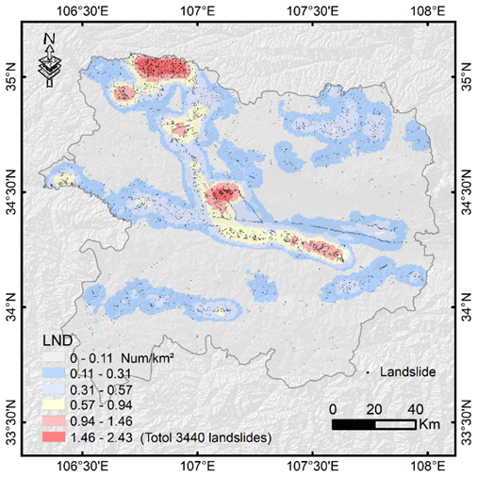

Figure 16. The LND distribution map derived from this study.

**Point 16:** *Figure 7.*

In the caption, correct the phrase “regional landslide concentration” to “distribution of landslides per elevation class”.

**Response 16:**

Thanks for your comments. We have made changes in the manuscript (please see Figure 9).

**Point 17:** *Figure 8.*

In the caption it is suggested to correct: “Statistics of landslide number versus” to “Landslide distribution in respect to …..

**Response 17:**

Thanks for your comments. We have made changes in the manuscript (please see Figure 10).

**Point 18:** *Figure 9.*

In the caption it is suggested to correct: “Statistics of landslide number versus” to “Landslide distribution in respect to …..

**Response 18:**

Thanks for your comments. We have made changes in the manuscript (please see Figure 11).

**Point 19:** *Figure 11.*

In the caption please correct “Land type” to “Land use type” or “Land cover”

**Response 19:**

Thanks for your comments. We have made changes in the manuscript (please see Figure 13).

**Point 20:** *5. Results. Line 207*.

Please correct to “large number of landslides is developed”

**Response 20:**

Thanks for your comments. We have made changes in the manuscript (please see line 225).

**Point 21:** *5. Results.* *Line 224*.

Please correct to “most of the landslides are located at...”

**Response 21:**

Thanks for your comments. We have made changes in the manuscript (please see line 242).

**Point 22:** *5.2.2. Geological factors.*

Land use type belongs to landslide causal factors but it cannot be included in the geological factors. It is suggested to either include it separately or, alternatively, it could be included it together with the topographical factors.

Regarding the geological factors please clarify if the “Quaternary strata” refer to the loess sediments or other geological formation/Quaternary deposits.

**Response 22:**

Thanks for your comments. We strongly agree with you that we classify land use type as topographic factors (please see line 265-269).

In the original manuscript, the term "Quaternary strata" refers to loess deposits, and I have changed the Quaternary strata to loess deposits for accuracy (please see line 271-274).

**Point 23:** *General remarks on Chapter 5.*

It is suggested the results of the landslide distribution within the study area and in respect to the different topographic, geological and hydrological factors to be also shown in tables. In this case it will be easier to the reader to identity and correlate in a qualitative way the main characteristics of the above factors that influence landslide activity.

**Response 23:**

Thanks for your comments. We have summarized the LND and LAP for the different variables in Table 4 (please see page 13-14).

**Point 24:** *Discussion. Line 353.*

Please do not use the term “ancient strata”. Do you mean that Quaternary deposits (No3) cover the older No 1 and No2, as mentioned geological formations?

**Response 24:**

Thanks for your suggestions, we have made changes in the manuscript (please see line 371-373).

**Point 25:** *Discussion.*

It is suggested the authors to provide some more information regarding their suggestions for further research in the study area in terms of landslide susceptibility mapping. For example, is of their intention to expand their research, including also other landslide causal and triggering factors (i.e. rainfall) or to proceed maybe to more detail investigation in selected landslides with specific field works, as for example field mapping at larger scale or landslide susceptibility assessment in the areas that have been classified as the ones with the higher landside frequency?

**Response 25:**

Thanks for your comments. It is a drawback that in the previous manuscript we did not look forward to future research. With your suggestions, we have discussed our future research priorities, which fall into three main aspects: 1) the landslide susceptibility mapping in Baoji; 2) to conduct more detailed investigations, including the type of landslide, the morphology of the landslide body, etc. 3) to analysis the occurrence mechanism and triggering factors of typical landslides based on the previous information (please see line 452-458).